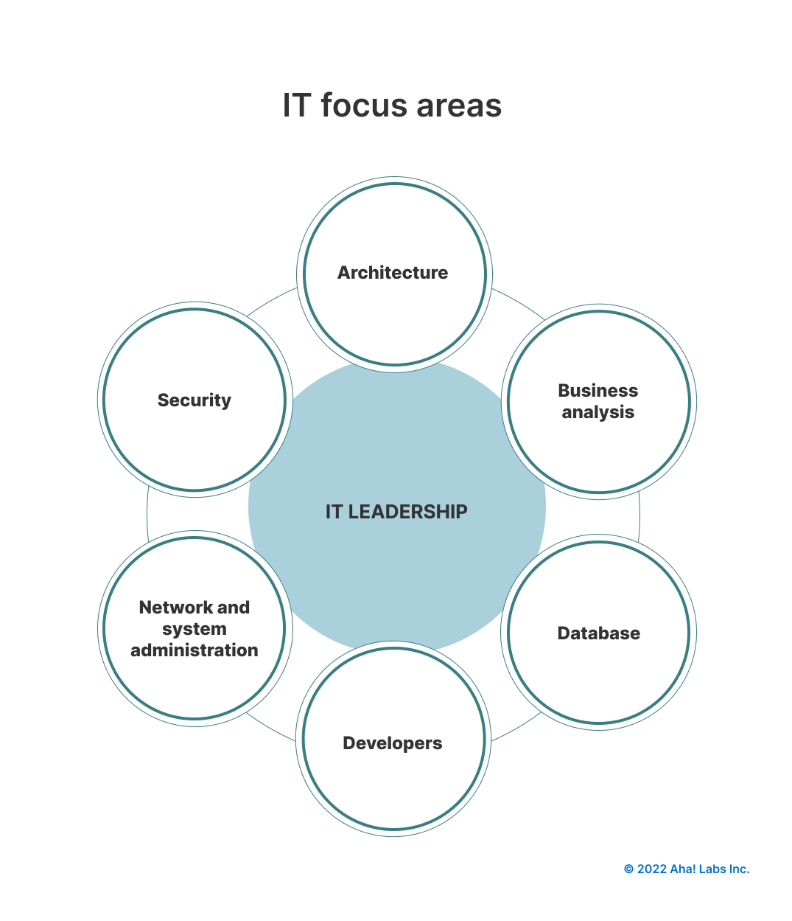

**IT leaders**.

* Chief information officer (CIO)
* Chief security officer (CSO)
* Chief technology officer (CTO)
* IT director & IT manager

**IT practitioners**

**Architecture job titles**

* Cloud infrastructure architect
* Enterprise architect
* IT systems architect
* Solutions architect
* Technical architect

**Network and system administration job titles**

* Computer systems manager
* Network architect
* Systems analyst
* IT coordinator
* Network administrator
* Network engineer
* Service desk analyst
* System administrator

**Database administration job titles**

* Database administrator
* Database analyst

**Business analyst and business intelligence job titles**

* Business analyst
* Data analyst
* Data analytics developer
* Data warehouse programming specialist
* Intelligence specialist

**Software development, DevOps, and cloud job titles**

* Back-end developer
* Cloud/software architect
* Cloud/software developer
* Cloud/software applications engineer
* Cloud system administrator
* Cloud system engineer
* DevOps engineer
* Front-end developer
* Full-stack developer
* Java developer
* Platform engineer
* [Release manager](https://www.aha.io/roadmapping/guide/information-technology/release-manager)
* Software engineer
* UI (user interface) designer
* [UX (user experience) designer](https://www.aha.io/roadmapping/guide/requirements-management/what-is-the-role-of-a-ux-designer)
* Web developer

**Security job titles**

* Application security administrator
* Artificial intelligence security specialist
* Cloud security specialist
* Cybersecurity hardware engineer
* IT security engineer
* Security systems administrator

**Help desk and customer support job titles**

* Help desk support specialist
* IT support specialist

**Project and product management job titles**

* [Project manager](https://www.aha.io/blog/the-product-manager-vs-project-manager)
* [Program manager](https://www.aha.io/blog/the-program-manager-vs-the-project-manager)

.